Courtney Krol
Dr. Rex
Honors 1000
23 September 2014

Detroit is Evolution

The world is ever-changing along with all of the much smaller pieces that make it up. Detroit is one just of these tiny pieces, but to the people who live here, it is their whole world. Detroit has changed in many ways over the past years: from its landscape to its architecture and from its population to its culture, nothing has stayed the same. However, all of these things have been affected by one major change: the economy and what drives it. This essay is going to focus on this factor and how one building, called the Highland Park Plant can symbolize its changes over time. The Highland Park Plant is a good representation of Detroit’s drastic economical evolution from an industrially based city to a new focus on historical preservation and education.
Detroit’s growth into an industrial economy actually had a lot to do with Ford’s growth and innovations at the Highland Park plant. In January of 1914, Ford announced his companies pay increase to 5 dollars a day, along with a shorter workday. (“Henry Ford’s…”) These changes attracted over 10,000 workers from all over the world to Detroit. By 1920, the Highland Park Plant employed 55,000 workers in 3 shifts: many of which came to the city just for an opportunity to work in the plant. ("Interactive…”) This represented the industrialization of the economy: a major economic and social development brought about by a technological advance. In this case the new technological advance being the Model T and the assembly line. For the city as a whole, this meant an influx of new citizens and the flow of money in many social settings. As stated by a reporter on motorcity.org, “No longer a region with a diversified economy, Southeastern Michigan had become dependent on the automobile industry for its growth and economic well-being.” The plant seems to still be the center of attention, even in its run down state, with surrounding buildings all being what you would expect to see in the epicenter of any town: a police station across the street, clothing stores, restaurants, and banks. The CVS next-door even shows a Model T on the front, displaying the importance of the building to the area. (Photos 1&2)
The downfall of the Highland Park Plant began in 1928 when the production of the Model T was moved to the River Rouge Plant in Dearborn. The plant was then only used for tractor production and automotive trim, because Ford needed a larger workspace for cars themselves. ("Interactive…”) In 1973 the site was named as a National Historic Landmark and production of anything in the plant was ended. ("Interactive…”) Shortly before this official end of use in the factory, the population in Detroit began to drop sufficiently as the industrial base of the city was relocated. This population drop began to even off around 2010 when the city began its revival. (Detroit Almanac)
Detroit has begun to be reinvented with a brand new economical focus on historical preservation and education. Like in many returning cities as people begin to come back to Detroit they want to restore it to its beauty and functionality. In our group discussion for example, Klevis thought the DIA was a better place to use to represent Detroit, because it is appealing to the eyes and is still fully functioning. For the Highland Park plant however, repurposing and recovery is well underway. In 2006, a Forman Mills clothing warehouse was opened, putting part of the old Ford plant to use, and as of 2013 the Woodward Avenue Action Association has been trying to revive other sections of the Highland Park Plant as a historic landmark. As with many of Detroit’s more significant buildings, it will serve as a museum of sorts. The company’s plan is to open the buildings as an automobile heritage welcome center with a theatre, multiple information kiosks, displays of automotive history, a gift and snack shop, and tours of the factories. Some of these tours would allow visitors to follow in the steps of Henry Ford himself. The WA3’s plan was to be open by 2018 and eventually allow people to access the entire site and tour the factories themselves. (Welch) This shows the focus and importance being placed on education in Detroit. Other buildings Detroit uses to push the knowledge of its history include the Detroit Historical Museum, the Dossin Great Lakes Museum on Belle Isle, and the Motown Museum.
In conclusion, the Highland Park Plant represents the very dramatic evolution of Detroit from its industrialized economy of the early 1900’s to its now developing practices of education into the history of the city. Detroit has a very intriguing background if people learn to just take a few moments from their busy lives to stop and listen. As people begin to relocate to Detroit the city will hopefully grow back to its once prosperous economy with this new twist on its focus.

1

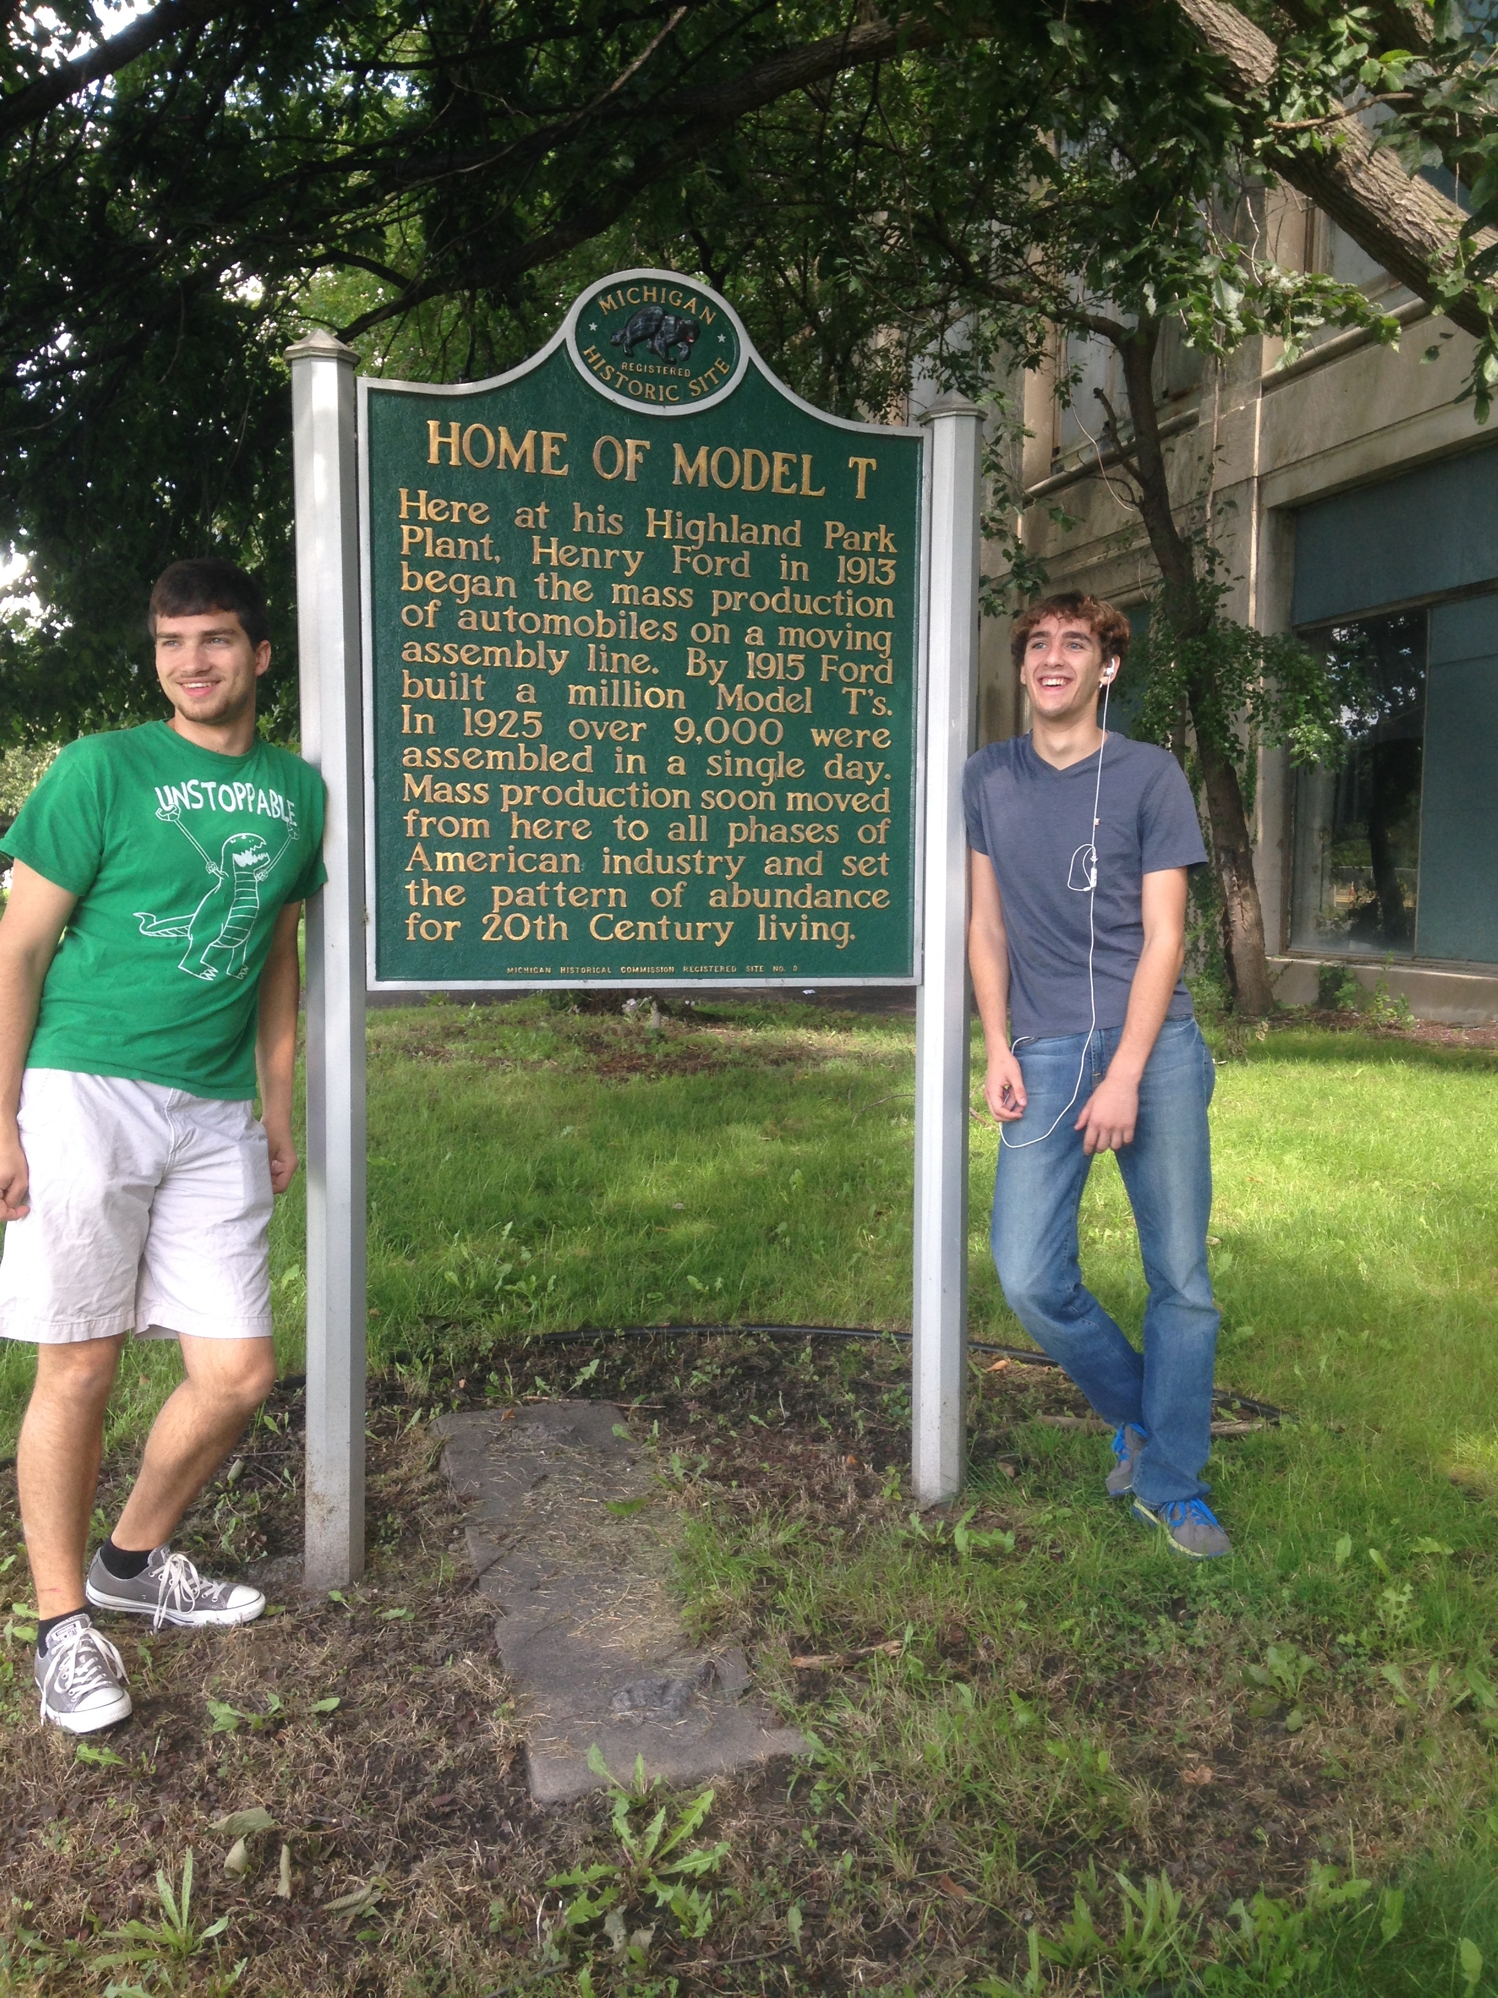
2
3
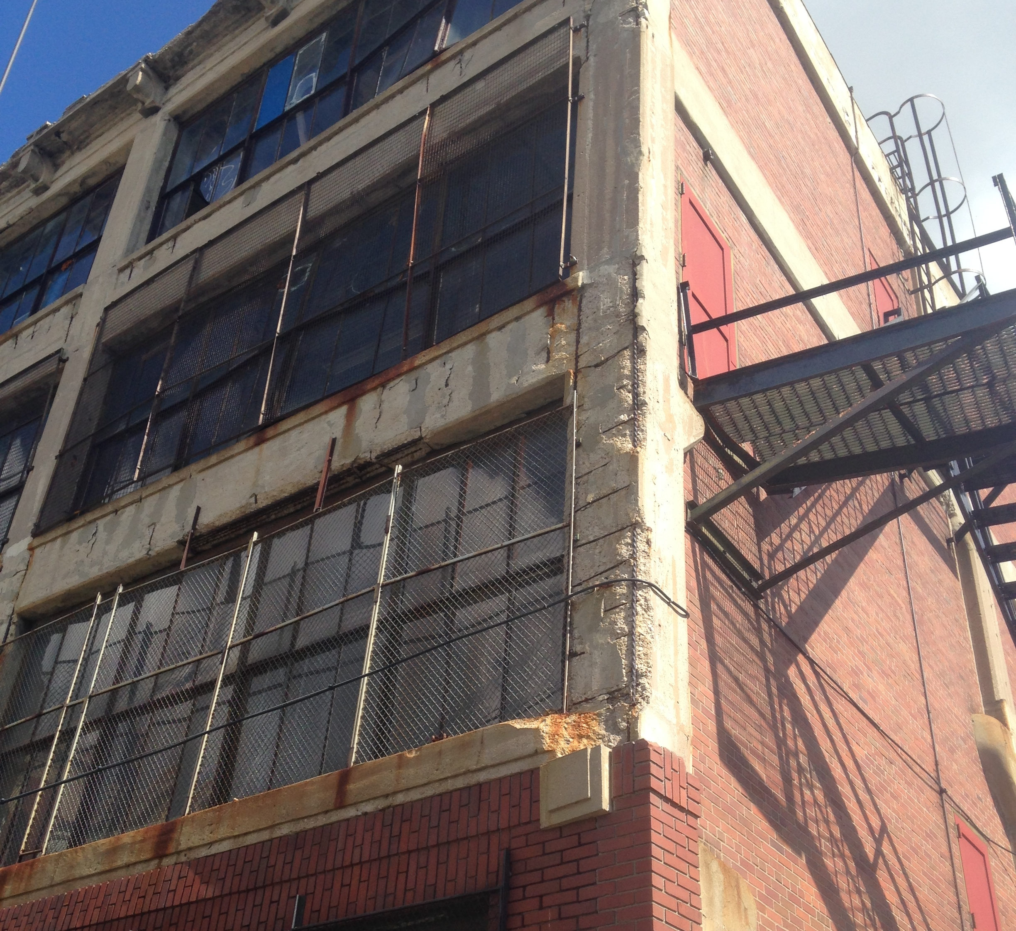
- Photo 1 shows the Model T displayed on the nearby CVS.

- Photo 2: shows broken down
bricks and shattered windows.

- Photo 3 shows members of my group at the Highland Park Plant with the sign in front of the building explaining the use of the Plant.

Works Cited

The Detroit Almanac. N.p.: Detroit Free, n.d. Web. 22 Sept. 2014.

“Interactive: Highland Park Timeline." The Detroit News. N.p., 16 Apr. 2007. Web. 20 Sept. 2014.

Welch, Sherri. Woodward Group Closer to Creating Auto Attraction at Historic Highland Park Plant. GALE. N.p., 15 July 2013. Web. 17 Sept. 2014.

"Henry Ford's $5-a-Day Revolution." - Press Release. N.p., n.d. Web. 16 Sept. 2014.

THE SIGNIFICANCE OF THE AUTOMOBILE INDUSTRY TO THE ECONOMY OF SOUTHEASTERN MICHIGAN (n.d.): n. pag. Motorcity.org. Web. 10 Sept. 2014.

